ARCH LINUX BASE INSTALL
=========================================================================

TIMELINE
Note: this is for UEFI GPT install
1.Connect to the internet
2. Disk (a.Partitioning b.Formatting c. Mounting)
3. Base install
4. fstab file
5. Enter install
6. Swap file “or you can partition a swap drive”
7. Time zone
8. Locales
9. Hostname
10. Hosts file
11. Root passwd
12. Boot loader / Essential packages
13. Exit install
14. Unmount and Reboot
15. Activate internet
16. New user
17. Graphics driver
18. Display server
19. Display manager
20. Desktop Environment /Essential apps

NOTE: case sensitive

1. Connect to the internet (wired is automatically detected this is for wirless)

Type in: $ iwctl
# device list “here you can see your available wifi devices example wlan0,1,2)
“then you need to scan for networks”
# station “your wifi device” scan
“then list all available networks”
# station “your wifi device” get-networks
“here is the command to connect”
# station “wifi device” connect “SSID” (wifi name you want to connect)
“if there are password just type it in the passphrase hit enter and then exit
back in archiso install test the connection by using # ping archlinux.org
and then finally type in # timedatectl set-ntp true

2. Disk
“ this will show all available blocks(hard disk ssd)”
# lsblk
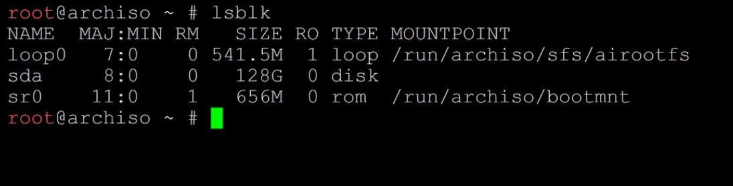

a) Partitioning
“ sda will be the main drive here we’ll use fdisk for creating the fat and ext4 partition”
# fdisk /dev/sda then g for GPT disk label n for new partition hit enter until last sector for boot
size type in +512M or desired size now for this one for the main system hit n and then hit enter all the way until last sector and set disired size for root or use all remaining space
then hit enter and then w for write and hit enter.
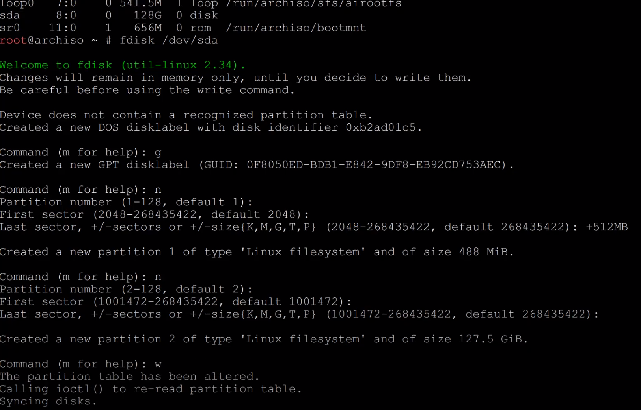

b) Formatting
“ we will format the 2 devices to fat32 for efi boot partition and sda2 for ext4 linux partition”
# mkfs.fat -F32 /dev/sda1
# mkfs.ext4 /dev/sda2
c) Mounting
“we will mount this partitions”
# mount /dev/sda2 /mnt “the mnt is the folder for the main system we are mounting it in sda2 because that is where the system / will be installed”
# mkdir /mnt/boot
# mkdir /mnt/boot/EFI
# mount /dev/sda1 /mnt/boot/EFI “boot partition”
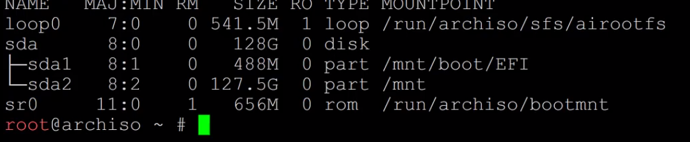
3. Base intsall
# pacstrap /mnt base linux linux-firmware nano “linux kernel and text editor base system”

4. fstab file
# genfstab -U /mnt >> /mnt/etc/fstab “fstab config where drives are automatically mounted”
# cat /mnt/etc/fstab “to check the drive details”

5. Enter Install
# arch-chroot /mnt “this will redirect you to the system / and now will be root@archiso /”

6. Swap file
“A swap file allows an operating system to use hard disk space to simulate extra memory. When the system runs low on memory I always use swapfile even tho I have 32gb or more ram just set to desired size”

# fallocate -l 4GB /swapfile
# chmod 600 /swapfile
# mkswap /swapfile
# swapon /swapfile
# nano /etc/fstab “this we will edit and put the swapfile to the fstab file”

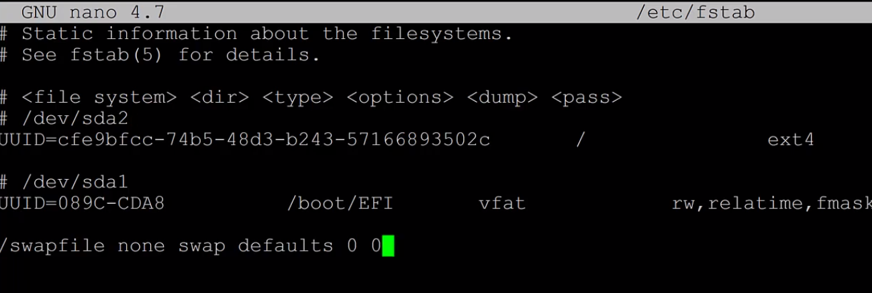
then exit and save ctrl+x

7. Timezone
# ln -sf /usr/share/zoneinfo/US/Pacific /etc/localtime “after zoneinfo you put your country and location”
# hwclock –systohc

8. Locales
# nano /etc//locale.gen “scroll down until you find your language for me its en_US.UTF-8 UTF-8 remove the pount key and save and exit”
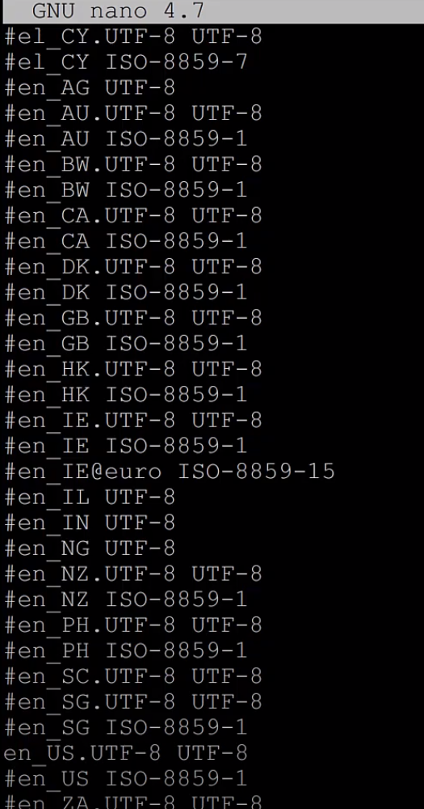

# locale-gen “generate the locale”
# nano/etc/local.conf “enter the string”
LANG=en_US.UTF-8 “ctrl+o or ctrl+z exit and save”

9. Hostname
# nano /etc/hostname “enter the of your machine in this case mine is “arch” then exit and save”

10. Hosts file
# nano /etc/hosts “config the host and add this from the image below”
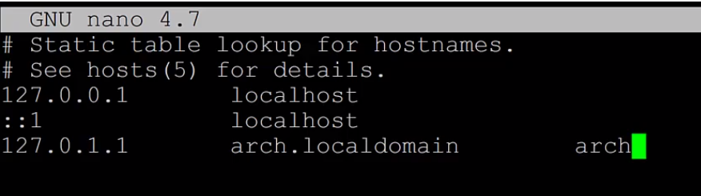
“save and exit”

11. Root passwd

# passwd “then enter your new password this is your root password”

12. Boot loader / Essential packages

# pacman -S grub efibootmgr networkmanager network-manager-applet wireless_tools wpa_supplicant os-prober mtools dosfstools base-devel linux-headers “hit enter and install”

# grub-install --target=x86_64-efi –-efi-directory=/boot/EFI –-bootloader-id=GRUB
# grub-mkconfig -o /boot/grub/grub.cfg “this installed and configured the grub bootloader”

13. Exit install
# exit

14. Unmount and reboot
# umount -a and # reboot “if the installation is good we will be greeted by grub bootloader and choose arch linux hit enter then login as root type your password and after that you will see root@”whatever host name you named your system” will show up”

15. Activate Internet
# systemctl enable NetworkManager
“for wifi”
# nmtui “hit enter choose edit/activate a connection and connect to the ssid then save and exit”
# systemctl enable NetworkManager “the enable command will start the service everytime the system is booted”

16. New user

# useradd -m -G wheel “desired name”
# passwd “name” and then type your new password
# EDITOR=nano visudo “give user sudo permissions”
“scroll down and remove pound key at whell ALL=(ALL) ALL”
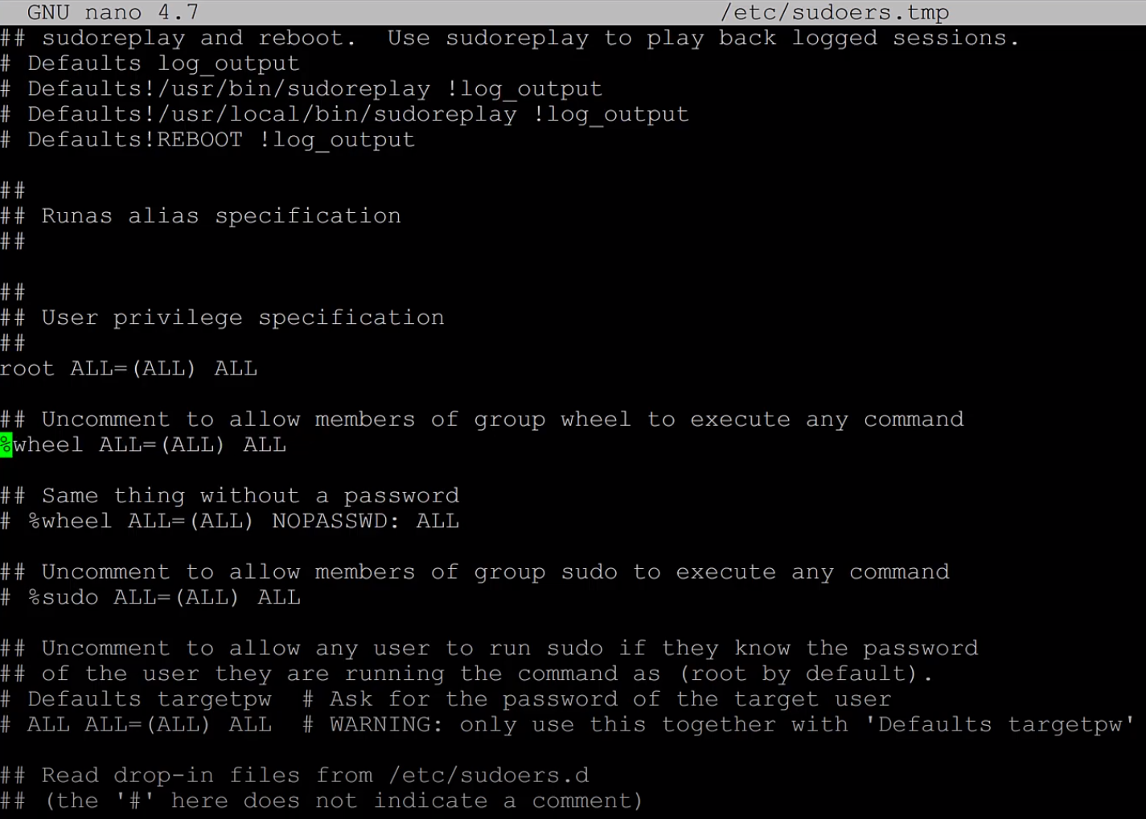
“save and exit”

17. Graphics driver
“this will differ when using intel integrated gpu or amd card or nvidia card here are the commands”
# pacman -S xf86-video-intel “for intel”
# pacman -S xf86-video-amdgpu “for amd gpu”
# pacman -S nvidia nvidia-utils nvidia-settings “for nvidia gpu”

18. Display Drivers / Display server
“xorg and wayland 2 primary linux display drivers I use xorg”
# pacman -S xorg

19. Display manager
“gdm for gnome sddm for kde xfce I use kde so I use sddm”
# pacman -S sddm
# systemctl enable sddm

20. Desktop environment / Essential apps
“for my build I use kde plasma this is my basic minimal desktop use for kvm”

# pacman -S plasma-desktop dolphin dolphin-plugins konsole konqueror powerdevil veracrypt bpytop neofetch ark fileflight gparted firewalld kwrite latte-dock plasma-meta pulseaudio git

# pacman -Syu “update the system”

SUMMARY: reboot, and if done right you will be greeted with a login screen plasma X11 post install check security setup firewall check for open ports remove unwanted apps note: base-devel you can acces the arch user repo make a folder in your home and clone packages that is not available in offical repo and enjoy.

